H.T No
Regulations:
A17

Sreenidhi Institute of Science and Technology
(An Autonomous Institution)
Code No: 6AC48 Date: 13-Nov-2020 (FN)

B.Tech II-Year II-Semester External Examination, Nov/Dec - 2020 (Supplementary)
Elements of Electrical and Electronics Engineering (ME)

Time: 2 Hours Max.Marks:75

Note: a) No additional answer sheets will be provided.
b) All sub-parts of a question must be answered at one place only, otherwise it will not be valued.
c) Missing data can be assumed suitably.

ANSWER ANY 5 OUT OF 8 QUESTIONS. EACH QUESTION CARRIES 15 MARKS.

1. | a) | Determine the current through 5Ω resistor by using reciprocity theorem?  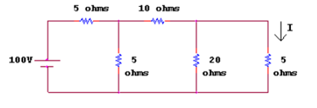 | [8M]
 | b) | Explain the construction details of DC machine with neat sketch. | [7M]
2. | a) | Illustrate an expression for impedance and current for series RL circuit in an AC circuit. | [8M]
 | b) | Derive the relation between line and phase voltages and currents in balanced Delta connected three phase system. | [7M]
3. | a) | Explain the working principle of Permanent magnet moving coil instruments. | [8M]
 | b) | Explain the working principle of operation of induction motor. | [7M]
4. | a) | Explain the construction and working of Zener diode. | [8M]
 | b) | Give the list of different filters used in rectifier and mention their merits and demerits. | [7M]
5. | a) | Explain the construction and working of MOSFET. | [8M]
 | b) | Explain input and output characteristics of a transistor in CC configuration. | [7M]
6. | a) | Implement the following Boolean function with NAND gates only.  F(X, Y, Z) = ∑m (1, 2, 3, 4, 5, 7) | [8M]
 | b) | Simplify the following boolean expression using Boolean Theorem  i).(A+B+C) (B+C) + (A+D) (A+C) ii). (A+B) (A+B) (A+B) | [7M]
7. | a) | Three resistances R₁₁, R₂ R₃ are connected in Star, derive the expressions for equivalent delta connection. | [8M]
 | b) | Derive the EMF equation of DC generator. | [7M]
8. | a) | For the circuit shown in the figure. Determine  i) Impedance ii) Total current iii) Phase angle?  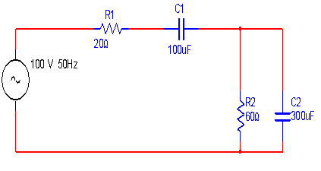 | [8M]
 | b) | Define the following terms of sinusoidal AC voltage  i) RMS value  (ii) average value  (iii) form factor  (iv) peak factor | [7M]

-- 00 -- 00 –

